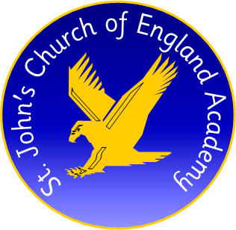

PE Apprentice required at St John’s CE Academy, Darlington, DL1 4UB

Required from September 2020
Are you looking for a career in sport and enjoy working with children? This is a fantastic opportunity to join a Level 2 Community Activator Coach apprenticeship (13 -15 months) through Sedgefield School Sports Partnership.
Closing date: Thursday 9th July
Interviews: Week beginning 13th July
For further information and to apply for this position please visit www.stjohnsceacademy.co.uk
Tel No: 01325 380725 (Mr Cooke) at St John’s CE Academy
Email: admin@stjohnsceacademy.co.uk
St John’s CE Academy
Fenby Avenue
Darlington
DL1 4UB

