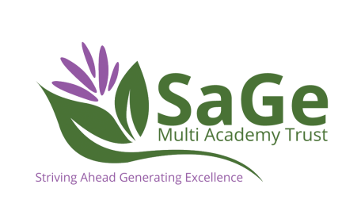

LEVEL 2 COMMUNITY ACTIVATOR COACH

Job Description
- In host school 4 days per week
- At college 1 day per week
- Supporting PE throughout the school day
- Support lunchtime and afterschool clubs
- Support in preparing teams for festivals
- Support within other curriculum areas in the classroom
- Support with administration of PE and School Sport
- Taking small cohorts of groups for activities
- Run sports, health and well-being projects within work setting

Personal Specification
Essential
- Passion for sport
- Experience of Sport Leadership
- Keen to learn
- Enjoys working with children
- Committed
Desirable
- Experience of supporting local community club
- Pass at GCSE Maths and English

Contract
- Wages are dependent upon age and previous qualifications but are in line with National Apprenticeship wages
- 13 – 15 months starting September 2020

Progression
- Level 3 TA Standard through PE
- Further Education
- Higher Education
- More equipped for employment

